Kathy Belcher
Cold Wax and Oil Artist

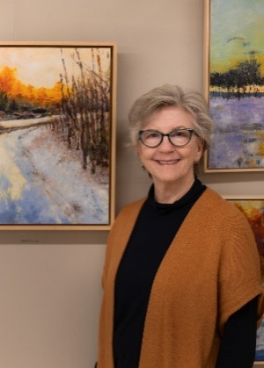
About the Artist
A lifelong learner, explorer and crafter with experience across a range of media – including fabrics, inks, acrylic, paper, watercolor and, most recently, oil and cold wax. My journey into cold wax and oils began in February 2020 during a vacation class, and the subsequent year and a half in Covid quarantine provided invaluable tie to research and further explore the medium. Although I came to painting late in life, I have expanded my skills through workshops, Beverly Street Studio School and online classes, continually striving to grow as an artist.

Artistic Process and Materials
Each of my artworks begins with three distinctly colored base layers of cold wax and oil, which add vibrancy and depth and serve as a foundation for scratching and mark making. I paint on Arches Oil Paper, later mounting it with archival medium onto a hard-surfaced panel board. The rigid support prevents movement of the paint layers and helps avoid cracking. I apply my paints using tools like squeegees and palette knives rather than brushes. Every piece receives at least two final layers of pure cold wax to protect its surface, resulting in works that are truly one of a kind.

Inspiration and Artistic Approach
As an artist who mainly works with oil and cold wax, I focus on creating landscapes that celebrate the beauty and wonder of nature. In my paintings, I use abstraction to blur familiar shapes, letting forms appear and disappear so viewers can interpret the scene in their own way. This approach helps create an intimate connection where each person's story weaves together with my artistic vision.

Color plays a vital role in my work. I use bold hues to inspire emotion and depth. My goal is to capture feelings of love and familiarity found in everyday life, inviting viewers to notice overlooked beauty and form their own connections through these abstract pieces.

Continuous Growth and Exploration
I am constantly challenging myself to try new painting styles and techniques, appreciating how the slow drying time lets me explore, revise and fully develop my ideas. I often work on a series of paintings, returning to earlier pieces after a few hours or days to add more layers. Some days, I am captivated by a particular color statement; on others, I am drawn to arranging intriguing textures.

Visit the Studio/Gallery
Visitors to Staunton are invited to stop by Suite 16 Studio/Gallery, 16A Byers Street, Staunton, Virginia (beside Byers Street Bistro). For inquiries, contact 540-290-3628 or email ColdWax302@gmail.com. More of Kathy’s work can be explored at kathybelcherart.com.

